A PYTHON PROGRAM TO IMPLEMENT KNN MODEL

**Ex.No.:9A**

**Date of Experiment:17/10/2024**

**AIM:-**

To implement a python program using a KNN Algorithm in a model.

**ALGORITHM:-**

Step1: Import all the other necessary libraries(numpy as np, matplotlib.pyplot as plt and sklearn.tree,pandas as pd and seaborn as sns).

Step2: Select the number K of the neighbors.

Step3: Calculate the Euclidean distance of K number of neighbors of data points. Step4: Take the K nearest neighbors as per the calculated Euclidean distance.

Step5: Among these k neighbors, count the number of the data points in each category.

Step6: Assign the new data points to that category for which the number of the neighbor is maximum.

Step7: Plot the graph “X” and “y” the values tested and predicted using seaborn.scatterplot() function.

Step8: Print the confusion matrix of the model to know the accuracy of the model with support values for each class.

**IMPLEMENTATION:-**

import numpy as np

import matplotlib.pyplot as plt import pandas as pd

dataset = pd.read_csv('../input/mall-customers/Mall_Customers.csv')

X = dataset.iloc[:,[3,4]].values print(dataset)

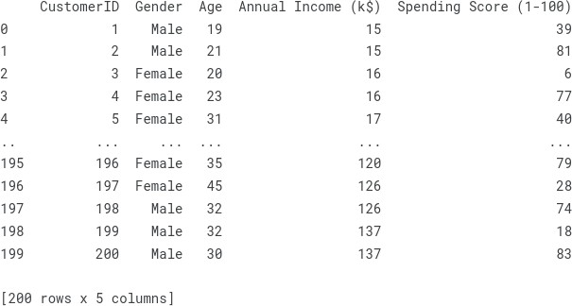

from sklearn.cluster import KMeans wcss =[]

for i in range (1,11):

kmeans = KMeans(n_clusters = i, init = 'k-means++', max_iter =300, n_init = 10, random_state = 0)

kmeans.fit(X) wcss.append(kmeans.inertia_)

# Plot the graph to visualize the Elbow Method to find the optimal number of cluster plt.plot(range(1,11),wcss)

plt.title('The Elbow Method') plt.xlabel('Number of clusters') plt.ylabel('WCSS')

plt.show()

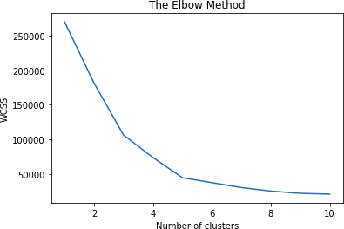

kmeans=KMeans(n_clusters= 5, init = 'k-means++', max_iter = 300, n_init = 10, random_state = 0)

y_kmeans = kmeans.fit_predict(X) y_kmeans

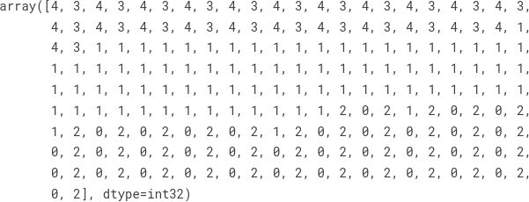

type(y_kmeans)



y_kmeans

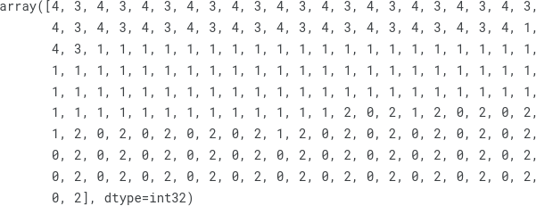

plt.scatter(X[y_kmeans == 0, 0], X[y_kmeans == 0, 1], s = 100, c = 'red', label = 'Cluster 1')

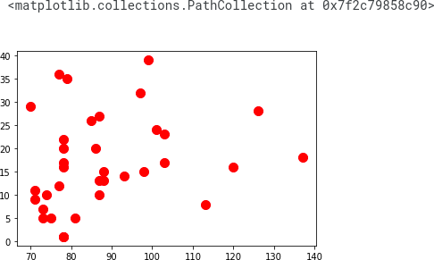

plt.scatter(X[y_kmeans == 1, 0], X[y_kmeans == 1, 1], s = 100, c = 'blue', label = 'Cluster 2')

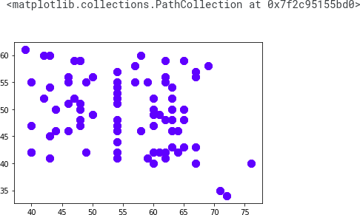

plt.scatter(X[y_kmeans == 2, 0], X[y_kmeans == 2, 1], s = 100, c = 'green', label = 'Cluster 3')

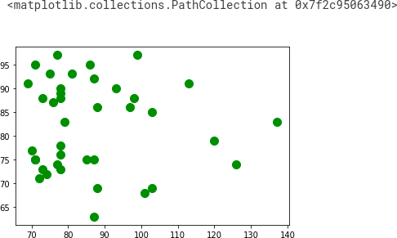

plt.scatter(X[y_kmeans == 3, 0], X[y_kmeans == 3, 1], s = 100, c = 'cyan', label = 'Cluster 4')

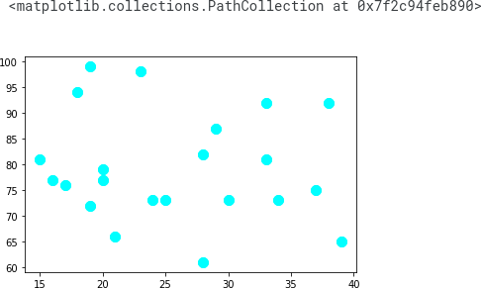

plt.scatter(X[y_kmeans == 4, 0], X[y_kmeans == 4, 1], s = 100, c = 'magenta', label = 'Cluster 5')

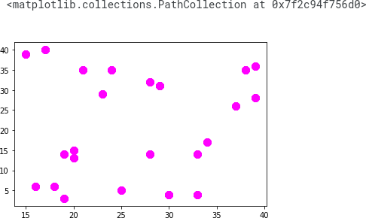

plt.scatter(kmeans.cluster_centers_[:, 0], kmeans.cluster_centers_[:, 1], s = 300, c = 'yellow', label = 'Centroids')

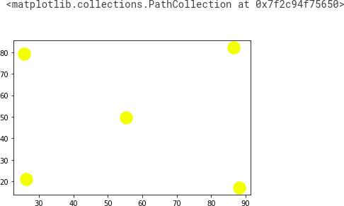

plt.title('Clusters of customers') plt.xlabel('Annual Income (k$)') plt.ylabel('Spending Score (1-100)')

plt.legend() plt.show()

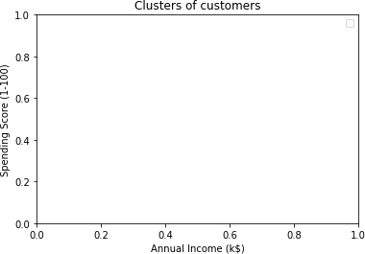

plt.scatter(X[y_kmeans == 0, 0], X[y_kmeans == 0, 1], s = 100, c = 'red', label = 'Cluster 1')

plt.scatter(X[y_kmeans == 1, 0], X[y_kmeans == 1, 1], s = 100, c = 'blue', label = 'Cluster 2')

plt.scatter(X[y_kmeans == 2, 0], X[y_kmeans == 2, 1], s = 100, c = 'green', label = 'Cluster 3')

plt.scatter(X[y_kmeans == 3, 0], X[y_kmeans == 3, 1], s = 100, c = 'cyan', label = 'Cluster 4')

plt.scatter(X[y_kmeans == 4, 0], X[y_kmeans == 4, 1], s = 100, c = 'magenta', label = 'Cluster 5') plt.scatter(kmeans.cluster_centers_[:, 0], kmeans.cluster_centers_[:, 1], s = 300, c = 'yellow', label = 'Centroids')

plt.title('Clusters of customers') plt.xlabel('Annual Income (k$)') plt.ylabel('Spending Score (1-100)') plt.legend()

plt.show()

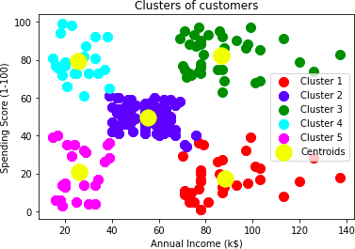

**RESULT:-**

Thus the python program to implement KNN model has been successfully implemented and the results have been verified and analyzed.